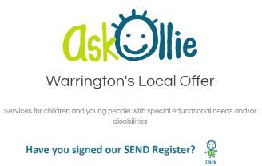
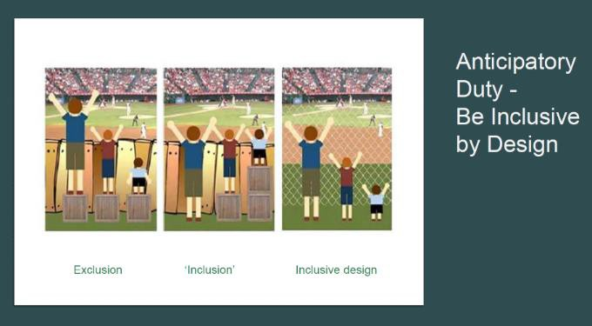

DittonPrimary School part of Warrington Primary Academy Trust SEND Report 2025 2026

This is the school SEND information and responses to questions from Halton LA Local Offer. Ditton Primary School is a primary academy part of Warrington Primary Academy Trust, catering for children between Reception to Year 6 (age range: 4 – 11). We value the individuality of all children and are committed to giving all our children every opportunity to achieve their full potential. We actively seek to remove the barriers to learning and this means equality of opportunities must be
a reality for all our pupils.

SENDCO : Mrs Paula Bate please contact via the main office on
0151 424 5861 pbate@wpat.uk

Policies related to DittonSEND report available on our website or by contacting our main office
- SEND Policy
- Early Help Offer
- Equalities Policy
- Behaviour Policy
- Attendance Policy
- Accessibility Plan

Halton Local Authority Halton Local Offer

HALTON SENDIASS - SEND Information, Advice and Support Service
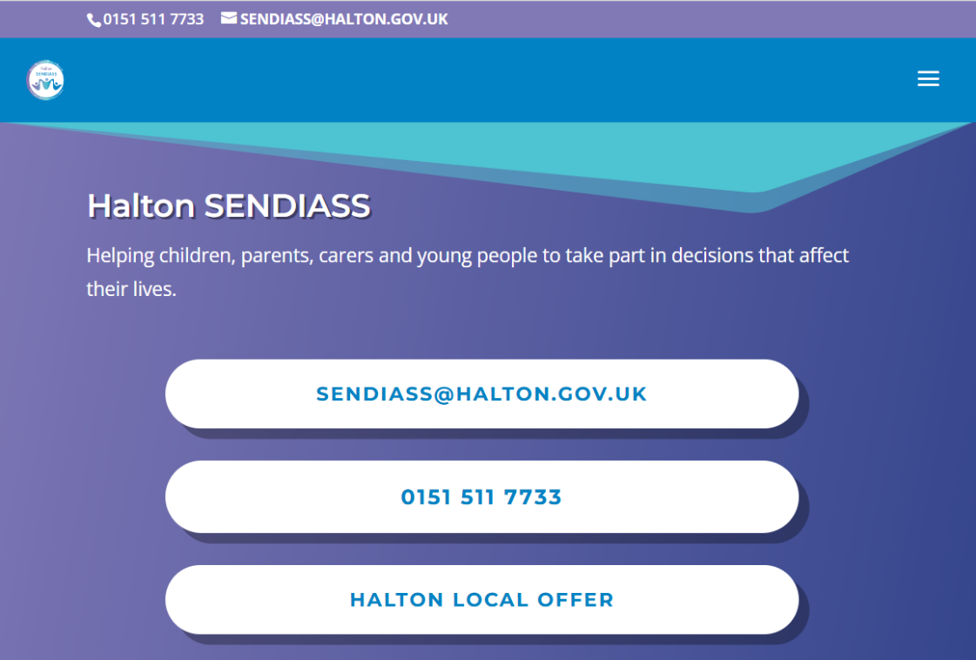
sendiasshalton.co.uk

An overview of the service
- All local authorities must provide access to a SENDIASS Service
- We are an independent service but we work closely with the local authority
- The advice we provide is impartial, confidential and free
- We help parents, carers and young people who have or may have special educational needs and disabilities aged between 0- 25 years. With or without an EHCP
- We provide information on what support and options are available to them, giving them the tools to make informed decisions about their child's/young person`s education and to express their views

How to contact us

Confidential telephone helpline, call us on 0151 511 7733. We have an out of hours answer phone available.
Face to face meetings by appointment at:

Answers to Parent and Carer Questions
1. | How does the school know if children/ young people need extra  help? | - Information may be received from previous settings, parents/ carers, other professionals in external agencies;  - Progress is significantly slower than that of their peers starting from the same baseline;  - Fails to match or better the child’s previous rate of progress;  - Fails to close the attainment gap between the child and their peers, and the attainment gap is widening; application of a Catch-Up programme does not help to diminish the gap.  - Development in self-help, social or personal skills is not in line with developmental age;  - Pupil’s behaviour is creating a barrier to learning, or social and emotional development is causing challenges and difficulties  - Trained staff provide on-going teacher assessments and tracking of pupil progress which will identify possible areas of need;  - Children may be identified as needing additional support through regular Pupil Progress meetings;  - Discussion with parents  - School use the graduated response to support early identification and next steps

2. | What do I do if I think my child has special educational needs? | - If there are any concerns, parents are encouraged to speak, in the first instance, to the child’s class teacher.  - Parents can also speak to our Special Educational Needs Coordinator (SENDCO), on their own, or with the child’s class teacher Mrs Paula Bate on 0151 424 5861  - If your child has not started at Ditton Primary, the SENDCO would be the first point of contact.
3. | How will the education setting staff support my child/ young person? | All of our class teachers are teachers of SEND and the school embraces an inclusive approach to whole school learning.  - The class teacher is responsible for daily differentiated lessons to suit all children’s specific learning needs including different learning materials or special equipment including computing resources;  - If a pupil has additional needs related to more specific areas of their education, then a ‘Pupil Passport’ and Provision Plan’ may be implemented following discussion between you, class teacher, pupil and SENDCO. Parents/ carers will be asked to sign a copy of the document once prepared. This document will provide specific targets that will be reviewed termly at Pupil Progress review meetings;  - Some group or individual targeted support (SMART targets are used) for specific learning needs;  - Research based interventions will be set up by the class teacher and SENDCO to support learning within the classroom. Extra adult time to devise the nature of the planned intervention and to monitor its effectiveness, of which will be evaluated half termly (minimum) by the class teacher, teaching assistant and SENDCO to ascertain the impact of the provision and to inform next steps;  - Interventions are recorded on a provision plan by teacher and teaching assistant;  - Occasionally, a pupil may need expert support from an outside agency. If they meet the criteria, referral forms are then completed in coproduction with parents/ carers and forwarded to the appropriate agency. That agency  may conduct a series of assessments, and following these, provide a programme of support to the school and/ or parents/ carers. The recommendations from professionals will be included within the ‘SEND Provision Plan’ and interventions. A record of the interventions is kept so that the impact and effectiveness of an intervention can be ascertained.  - Our Provision Plans and Provision Map are reviewed half termly by the SENDCO, SEND team, senior leaders and class teachers.  Training is provided throughout the year to teachers, support staff and whole school staff to ensure that all are up to date with the latest SEND policies and practices.

4. | How will the curriculum at your education setting be matched to my child/ young person’s needs? | 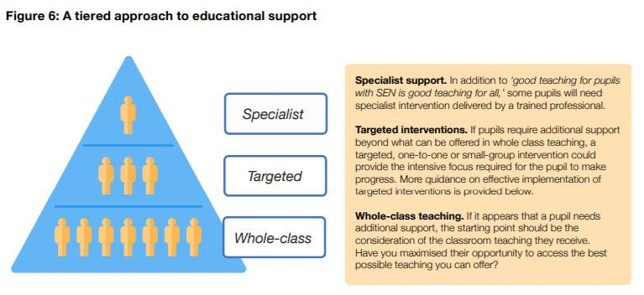  At Ditton we set challenging and inspirational targets for every pupil whatever their prior attainment. We use rigorous formative and summative assessments to set these targets and plan a differentiated curriculum to meet the needs of individuals within the class.  Potential areas of difficulty are identified and any barriers to learning and achievement are clearly assessed so that these can be planned for within the curriculum to ensure targets are achieved.  In a case where it is not possible to meet these needs then additional or different provision is planned. We will  do what is necessary to enable pupils to: develop, learn, participate and achieve the best possible outcomes.  If a child is identified as having SEND:  - The curriculum is adapted or differentiated in different ways according to a child’s needs and recorded on the school’s Provision Map. The ‘Waves of provision’ approach is taken:  - WAVE 1 Quality First Teaching (QFT) – class teachers routinely use their knowledge of pupil’s levels and learning styles to differentiate work to match children’s needs;  - WAVE 2 differentiation – If pupils have been identified with specific needs, their work may need to be further differentiated, to remove barriers to learning and enable them to access the curriculum more  easily.

- WAVE 3 differentiation – If the school feels it is appropriate, specialist equipment, resources or a learning programme may be made available.

- Teaching Assistants (TAs) in school provide support to teacher across Waves 1, 2 and 3 provisions. TAs may work with a child 1:1 on specific focused tasks or in a small intervention group and this will be planned by the class teacher and SENDCO.
- Specialist equipment may be given to a pupil to help them, such as a visual timetable, a wobble cushion, or adapted equipment.
- Work may be differentiated by outcome, pace of completion, support offered or by breaking it down into smaller chunks.
- Pre and post learning opportunities and support may be offered if appropriate.
- If the child has received support from outside agencies such as EP (Education Psychologist) support or SALT (Speech and Language Therapy) support, these programmes and recommendations will be incorporated into the child’s learning; outlined in their individual provision plans and one page profile (pupil passport).
5. | How will both you and I know how my child is doing and how will you help me to support my child’s learning? | - Through regular discussions with the class teacher and any teaching assistants who work with your child’s class/ group.  - Teaching staff are usually available at the end of the day for short informal discussions; longer appointments can be made with the class teacher, or the SENDCO, through the Class Dojo system or school office.  - For EYFS to Year 6, curriculum overviews are produced half termly, sent home to parents/ carers, and published on our website. These are produced to outline the subject content and topic links children will cover each half term/ full term so that parents/ carers can support their child at home.  - Parents’ Evenings are held twice a year, in the first half term of the autumn term, and towards the end of the second half term of the spring term. An option to meet class teachers after the end of year report is also available. In addition to this, parents/carers will receive a data report to aid understanding of how well their child is doing against age related expectations and in terms of their effort and progress.  - A full written report will be sent home near the end of the academic year.  - The class teacher may occasionally make extra notes in a home school link book or reading record, if the teacher or SENDCO feel this is necessary.  - Pupil Passports are drawn-up in consultation with parents/ carers and children and will be reviewed half termly.  - Provision plans are reviewed half termly  - Annual Review meetings are held for children with an Education & Health Care Plan (EHCP).  - If an external agency is coming into school to assess your child, provision will be made for you to meet with them and discuss your child and any thoughts you have about their progress, additional needs, aspirations, etc.  - Recommendations received from an external agency are discussed with parents/ carers and pupils (at age appropriate level); copies of reports will be shared also.

- If a child has specific medical needs, staff will always meet with you and a health worker (if involved) to write a medical care plan.
- If your child has a Behaviour Provision Plan in place at the school then fortnightly meetings may be held to review the document with the class teacher and/or a member of the SLT (Senior Leadership Team).
6. | What support will there be for my  child’s overall emotional health and wellbeing? | - All staff offer pastoral support for children.  - Halton Early Help OfferParents/Carers - Halton Safeguarding Children Partnership  - Within our Safeguarding team, we have a full-time dedicated Safeguarding Lead Mrs Katie Scott deputy Safeguarding Lead, Mr Graeme Bourque and Mrs Catherine Hubball and Attendance officer Mrs Noone. They are available for pupils who wish to discuss issues and concerns.  - Dependent on needs identified, some specific nurture work/ programmes may be implemented by support staff with support from the school’s safeguarding team or SENDCO.  - Our Safeguarding Team support emotional health and wellbeing, and also supports teaching staff as they support children. They all access regular update training.  - We have comprehensive policies to deal with medical issues, based on current good practice and accepted guidelines.  - If all school support has been exhausted, the school has access to external agencies and professionals, to support with behaviour, attendance and emotional wellbeing. Currently external agencies used in school include but are not limited to play therapy, Specialist Teachers and Educational Psychologist  - Futures in Mind support
7. | What specialist services and expertise are available at or accessed by the education setting? | We are supported by a range of professionals who we can access support from as appropriate; some of these specialist services and experts are provided through the Local Authority, and some are independently resourced. The range includes:  - Educational Psychologist  - Speech and Language team  - Occupational Therapy  - Inclusion teachers for learning  - Sensory Support (Hearing and Visual Impairment)  - SEND Orthoptist  - School Health  - Social Services  - CAMHs (Child & Adolescent Mental Health Services)  - Child protection/ safeguarding team  - Play therapy

- Physiotherapist
- Medical professionals such as epilepsy team
- ASD/ ADHD specialist nurse
- Futures in Mind

Access to these services is prioritised according to need and availability. This would be dependent on school judging that the child meets the required criteria for this support.
8. | What training are the staff supporting children and young people with SEND had or are having? | - The SENDCO is a qualified teacher who has the National Award for Special Educational Needs Co-ordination.  Those staff working with children with speech and language difficulties will be supported by the SENDCO and are trained in speech and language programmes.  - The SENDCO attends regular SEND training within the Local Authority, WPAT Network and other clusters to maintain up to date knowledge of SEND practice and to share and develop good practice.  - Some staff have had specific recent training related to individual children, for example, to provide physiotherapy programmes, about medical conditions, etc.  - If a child has been supported by the Visual Impairment Team or Educational Psychologist the year group will be supported by these services and the SENDCO to implement specific programmes and interventions.  - Staff have also received training for managing behaviour linked to PDA (Pathological Demand Avoidance) and mental health Bereavement training
9. | How will my child be included in activities outside the classroom including school trips and provision for access to afterschool clubs? | - Ditton endeavours to include all pupils in all activities and will work closely with parents/ carers to try to ensure barriers to participation are removed and reasonable adjustments made wherever possible.  - A risk assessment will be carried out for individual’s participation where required; this will be verbally shared with pupils and families where appropriate to ensure the correct provision is in place.  - Trips and activities are available to all.  - In some circumstances, we may ask a parent/ carer to accompany their child on a trip or activity to enable them to safely access it. This would be considered through the risk assessment process.  - Adapt and increases accessibility of information readily available to pupils who are not disabled on an individualised provision basis
10. | How accessible is the Ditton Primary school environment? | Our building is accessible through:  - Accessibility plan and yearly audit  - The main building is fully accessible and consists of a ground floor, with easy access to both the Office Entrance and the KS2 entrance.

- There are a number of accessible toilets for children and adults situated around the school, including a designated disabled toilet.
- As a school we are happy to discuss individual access requirements and we will make reasonable adjustments wherever possible. We carefully consider the layout and use of the building in relation to the needs of the individual child in order to meet their needs appropriately.
- School carry out an Accessibility Audit annually or in response to a new need being identified.
11. | How will the education setting prepare and support my child to join high school, transfer to a new education setting or the next stage of education and life? | - The SENDCO liaises with other settings at the point of transition, both into school in the early years, and out of school to secondary education.  Child entering Reception:  - When children enter Reception, there are a lot of visits between their nursery setting and school, where the Reception Teacher and SENDCO will meet with the child and team. Extra visits and meetings will be set up as required. Our minimum transition offer is a school visit – introduction and play in the setting, a home visit and a nursery provision visit from Miss Horton and Mrs Williams. Additional transition plans can be arranged with Miss Horton (Reception teacher and Mrs Williams Teaching Assistant) to reflect individual needs  - Transition within school from one year group to another is carefully planned with individual pupil’s needs discussed prior to visiting their new classroom; handover of certain documents for key information, such as: Pupil Passports, data, record of interventions. Transition meetings focus on individual pupil needs. At Ditton provide children with a Transition Days held at the end of the Summer Term, where pupils will spend time with their new teacher and complete projects together. Transition for pupils with SEND may require a differentiate approach and through discussion with the parents/ carers and child, teaching staff will adapt the transition period as needed.  - When a child joins from another setting, the school makes contact with that setting to support transition.  Similarly if a child leaves during school, Ditton staff will endeavor to liaise closely with the receiving setting.  - The school endeavors to listen and take account of views of parents and carers regarding the needs of pupils with SEND when they join school.
12. | How are Ditton’s resources  allocated and matched to children’s special educational needs? | Children with an EHC plan will have their own budget to support them. Money is used to provide recommended resources or to deploy staff, or to access specialist training.  - The school’s provision mapping identifies categories of need on an individual, group, class and whole school basis. Funds are allocated to best meet the needs of pupils and spending is regularly reviewed.

 |  | - Further support or resources may be allocated to your child following assessments by the SENDCO, or outside agencies (e.g. children’s Speech and Language Therapy team).
13. | How is the decision made about what type and how much support my child will receive? | - The Head teacher and SENDCO will allocate resources and support based on a child’s individual needs, following discussions with the class teacher and where appropriate, advice from external professional agencies and parents/ carers. This will be in line with the SEND Code of Practice.  - The allocation of support will be informed by the school’s own internal assessment procedures and any external professional reports. Any plans or interventions will be discussed with parents/ carers and reviewed regularly.  - Support will be reviewed and change according to the ongoing review of need which will be discussed with staff, parents/ carers and child.  - Through Pupil Progress Meetings and discussions between school based staff around the child.  - For pupils with an EHC plan, further consultation will take place with all stakeholders to determine support ‘addition to and different from’ that which is available to school.  - EHC plans should specify how services will be delivered as part of a whole package and explain how best to achieve the outcomes sought across education, health and social care for the child or young person.  - The information gathered during an EHC needs assessment may indicate ways in which the school can meet the child or young person’s needs without an EHC plan.
14. | How are parents involved at Ditton Primary? How can I be involved? | All parents/ carers are encouraged to contribute to their child’s education. This may be through:  - Discussions with the class teacher;  - During parents evenings or other arranged meetings;  - During discussions with the SENDCO, or other professionals;  - Parents/ carers are encouraged to comment on their child’s Pupil Passport and Provision Plan;  - Parents/ carers are warmly encouraged to support and help with school activities, or to volunteer/ help out in the classrooms (subject to DBS);  - We offer concerts, assemblies, sporting events, and curriculum workshops to which parents/ carers are invited.  In EYFS, parents/ carers are invited to a Stay & Play session.
15. | Who can I contact for further information? | If you wish to discuss your child’s educational needs, please contact one of the following:  - Your child’s class teacher or the Teaching Assistant who works in their classroom or with your child.  - SENDCO – Mrs Paula Bate  - Head teacher – Mrs Biz Killalee  - SEND Link Governor – Mrs Rebecca Littler  Appointments can be made with any of these people through the school office on 0151 424 5861

 | Answers to Children’s Questions
1. | How does the school know if I need extra help? | - Through something that you or your parents/ carers have told us.  - We might have noticed that you are struggling with work in class. Your behaviour or attitude might tell us that you need support. You may not be making the usual progress in your work.
2. | What should I do if I think I need extra help? | - Speak to your parents/ carers and ask them to have a word with your teacher.  - Speak to your teacher or another adult who works in your class.  - You can add a comment to your work to tell the teacher.  - All adults in school will want to help and support you, including other teachers you have worked with, including our support staff and members of the safeguarding team (on display in the front entrance and around the key stage corridors).
3. | How will my work be organised to meet my individual needs? | - We can differentiate your work in different ways.  - We can give you different resources to help you.  - We can break your work into smaller chunks.  - You can monitor your own progress and see your successes.  - We can give you some extra work on a new topic before you start it so you feel more confident.  - We may give you help in a small group to help you learn a new skill.  - We will listen to you and understand what you find difficult so that we can offer the right kind of support.  - We will give you additional support should you need it.
4. | How will I be involved in planning for  my needs and who will explain it and help me? | - Your class teachers and teaching assistants will speak to you.  - You will be involved in reviewing and planning targets. You will discuss how you learn best using your pupil profiles.



5. | Who will tell me what I can do to help myself and be more independent? | - The adults who work with you will support you.  - You might have a list of what you need to do written for you or a visual timetable or a ‘Now and Next’ board.  - Your teacher and TA will set you targets to help you and break big tasks into smaller ones.  - We do lots of lessons and assemblies in school to develop resilience, risk taking, resourcefulness, reflection and good relationships. Everyone has targets (e.g. written feedback from teacher, specific targets from teacher) to get better at these things and so will you (with lots of help along the way).
6. | What should I do if I am worried about something? | - Speak to a friend, a parent or carer, or an adult in school – we all care and want to help! If you worry a lot, you may have a worry book/ diary and use that to communicate with adults at home and school.  - Specific strategies may be used as appropriate, e.g. worry boxes may be in place or a specific adult I school to talk to when worrying.
7. | How will I know if I am doing as well as I should? | - We will talk to you regularly.  - When your teachers mark your work, they will tell you.  - Your teacher and TAs will give you feedback during lessons.  - Adults will review your targets with you.  - You can ask your teacher if you are doing well.
8. | How can I get help if I am worried about things other than my work? | - Talk to us about what is worrying you and we will work with you and find people to support you.  - You can tell your teacher, TA, or any member of the school staff.  - Talk to our Assistant Pastoral Lead - Mrs Wilcock.
9. | Are there staff in school who have had special training to help young people who need extra help? | - All of our teaching staff have regular training in areas of SEND.  - All staff are trained in lots of intervention programmes to help you with your learning.  - We have a training SENDCO and our Learning Mentor access a range of training to offer support.  - We have lovely Teaching Assistants who are trained to help you when you feel sad, worried, anxious, or unconfident.
10. | Can school staff get extra help from experts outside the school if they need to? (e.g. advice and training on medical conditions) | Yes we can! We can get help from lots of different professionals to help with your needs as appropriate, including:  - Educational Psychologist  - School Health Adviser  - Occupational Therapist  - Parent Partnership

- Early Help team
- CAMHs
- Counselling services, such as St Joseph’s, NSPCC
- Visual and Hearing Impairment team
- Speech and Language team
- Orthoptist
- Physiotherapist
- ASD/ ADHD specialist nurses
- Play therapy
- Medical professionals such as epilepsy team
- And more!
11. | If I have difficulty in taking part in school activities what different arrangements can be made? | - How will I know who can help me?  Talk to a member of staff with your parents/ carers or on your own and together you can come up with a plan.  - Who can I talk to about getting involved in student activities if I need extra help?  If you want to get involved in an activity, we will make sure that you can and give you the help you need. Talk to one of the adults in your classroom or with your parent/carer who can also speak with us to facilitate additional needs.
12. | What help is there to help me get ready to start school? | - We will speak to you and your parents/ carers before you start. We will visit you at your nursery or speak to your previous school so that we have lots of information.  - We will usually hold a meeting with the people who help you now so that we have everything in place to help you.  - We will speak to your new school before you start. We will make sure that you can visit and meet the people who will help you before you start. We will keep you in touch with your new school to make sure they know how to help you.
13. | I am coming to school to prepare for employment – how will I be supported? | - We will listen to your dreams and aspirations.  - We will regularly invite people from the world of work into school to tell you about their jobs, and to inspire you to be prepared for employment.  - We will encourage and support you.  - We will help you develop social skills, good relationships, resilience, and confidence to take risks, resourcefulness, and independence and reflection skills.  - We will see you as an individual.

