

Ditton Primary Academy School

Relationships Education Policy

2025

2026

Policy Responsibilities and Review

|  |  |
| --- | --- |
| Policy type: | School |
| Guidance: | This policy has been developed in consultation with staff, pupils and parents |
| Related policies: |  |
| Review frequency: | Annually |
| Committee responsible: | Local Governing Committee |
| Chair signature: |  |
| Changes in latest version: | Detail changes, if any, since last reviewed |

Contents

1. Definition 4

2. Aims 4

3. Statutory requirements 4

4. Policy development 5

5. Curriculum 5

6. Delivery of Relationship Education 6

7. Roles and responsibilities 7

7.2 The Headteacher 7

7.3 Staff 7

7.4 Pupils 8

8. Parents’ right to withdraw 8

9. Training 8

10. Monitoring arrangements 8

11. Appendix 1: Curriculum map 9

1. RELATIONSHIPS EDUCATION (PRIMARY) .................................................................................................................. 11
2. HEALTH EDUCATION (PRIMARY) ...................................................................................................................................... 14

# 1. Definition

Relationships and Sex Education (RSE) is about the emotional, social and cultural development of pupils and involves learning about positive relationships, healthy lifestyles, diversity and personal identity. It involves a combination of sharing information, and exploring issues and values.

Relationships education focuses on teaching the fundamental building blocks and characteristics of positive relationships including:

Statutory aspects of sex education are covered in the science curriculum.

# 2. Aims

Ditton Primary, as part of Warrington Primary Academy Trust teach Relationships Education following guidance from the DfE and the PHSE Association. This ensures that age appropriate learning is mapped into our programmes of study. Key Elements are provided in Appendix 1 and 2 for information.

Biological aspects of sex education are taught within the Science Curriculum and they are again designed to be age appropriate. Our aims for RSE are to:

* Provide a framework in which sensitive discussions can take place

* Prepare pupils for puberty, and give them an understanding of sexual development and the importance of health and hygiene (as per science curriculum)

* Help pupils develop feelings of self-respect, confidence and empathy

* Create a positive culture around issues of sexuality and relationships

* Teach pupils the correct vocabulary to describe themselves and their bodies

The first of our core values is Children First – Everything we do is in the interest of children first and foremost

# 3. Statutory requirements

As a primary academy, we must provide relationships education to all pupils under section 34 of the Children and Social Work Act 2017.

We don’t have to follow the National Curriculum, but we are expected to offer all pupils a curriculum that is similar to the National Curriculum including requirements to teach science. This would include the elements of sex education contained in the science curriculum.

In teaching RSE, we’re required by our funding agreements to have regard to guidance issued by the secretary of state, as outlined in section 403 of the Education Act 1996.

We also have regard to legal duties set out in:

* Sections 406 and 407 of the Education Act 1996
* Part 6, chapter 1 of the Equality Act 2010
* The Public Sector Equality Duty (as set out in section 149 of the Equality Act 2010). This duty requires public bodies to have due regard to the need to eliminate discrimination, advance equality of opportunity and foster good relations between different people when carrying out their activities Refer to your funding agreement and articles of association for more information. At [school name], we teach RSE as set out in this policy.

As a primary academy school we must provide relationships education to all pupils as per section 34 of the [Children and Social work act 2017.](http://www.legislation.gov.uk/ukpga/2017/16/section/34/enacted)

We do not have to follow the National Curriculum but we are expected to offer all pupils a curriculum that is similar to the National Curriculum including requirements to teach science which would include the elements of sex education contained in the science curriculum.

In teaching RSE, we are required by our funding agreements to have regard to [guidance](https://www.gov.uk/government/consultations/relationships-and-sex-education-and-health-education) issued by the secretary of state as outlined in section 403 of the [Education Act 1996.](http://www.legislation.gov.uk/ukpga/1996/56/contents)

RSE is taught in compliance with the relevant requirements of the Equality Act 2010 and schools advice. RSE is taught in compliance with the SEND Code of Conduct (see section 10: Pupils with SEND)

At Warrington Primary Academy Trust we teach RSE as set out in this policy.

# 4. Policy development

This policy has been developed in consultation with staff, pupils and parents. The consultation and policy development process involved the following steps:

1. Review – a member of staff or working group pulled together all relevant information including relevant national and local guidance

1. Staff consultation – all school staff were given the opportunity to look at the policy and make recommendations

1. Parent/stakeholder consultation – parents and any interested parties were invited to attend a meeting about the policy

1. Pupil consultation – we investigated what exactly pupils want from their RSE

1. Ratification – once amendments were made, the policy was shared with governors and ratified

# 5. Curriculum

Our curriculum is set out as per Appendix 1. The curriculum may need to adapted in response to changes in cohorts and to reflect changes in the wider world. Any changes made will be available on the website.

We have developed the curriculum in consultation with parents, pupils and staff, taking into account the age, needs and feelings of pupils. If pupils ask questions outside the scope of this policy, teachers will respond in an appropriate manner so they are fully informed and don’t seek answers online.

Primary sex education will be delivered as a component of the Science Curriculum only and will focus on:

Science KS1: notice that animals, including humans, have offspring which grow into adults

Science KS2: describe the difference in the life cycles of a mammal, an amphibian, an insect and a bird, describe the life process of reproduction in some plants and animals, and describe the changes as humans develop to old age

For more information about our curriculum, see our curriculum map in Appendix 1.

# 6. Delivery of Relationship Education

Our Curriculum Map shown in Appendix 1 breaks down the course of study into the following sections.

Appendix 2 provides further detail of the content for each section.

* Families and people who care for me

* Caring friendships

* Respectful relationships

* Online relationships

* Being safe

These areas of learning are taught within the context of family life taking care to ensure that there is no stigmatisation of children based on their home circumstances (families can include single parent families, LGBT+ parents, families headed by grandparents, older siblings, adoptive parents, foster parents/carers amongst other structures) along with reflecting sensitively that some children may have a different structure of support around them (for example: looked after children or young carers).

We will also be mindful of the law and legal requirements, taking care not to condone or encourage illegal political activity, such as violent action against people, criminal damage to property, hate crime, terrorism or the illegal use of drugs.

RSE is taught within the personal, social, health and economic (PSHE) education curriculum.

Biological aspects of RSE are taught within the science curriculum, and other aspects are included in religious education (RE).

### 6.1 Inclusivity

We will teach about these topics in a manner that:

* Considers how a diverse range of pupils will relate to them

* Is sensitive to all pupils’ experiences

* During lessons, makes pupils feel:

* Safe and supported
* Able to engage with the key messages

We will also:

* Make sure that pupils learn about these topics in an environment that’s appropriate for them, for example in:

* A whole-class setting
* Small groups or targeted sessions
* 1-to-1 discussions
* Digital formats

* Give careful consideration to the level of differentiation needed

**6.2 Use of resources**

We **will** consider whether any resources we plan to use:

* Are aligned with the teaching requirements set out in the statutory RSE guidance
* Would support pupils in applying their knowledge in different contexts and settings
* Are age-appropriate, given the age, developmental stage and background of our pupils
* Are evidence-based and contain robust facts and statistics
* Fit into our curriculum plan
* Are from credible sources –PSHE Association
* Are compatible with effective teaching approaches
* Are sensitive to pupils’ experiences and won’t provoke distress

# 7. Roles and responsibilities

### 7.1 The Governing Body

The Governing Committee will approve the RSE policy, and hold the Headteacher to account for its implementation.

## 7.2 The Headteacher

The Headteacher is responsible for ensuring that RSE is taught consistently across the school, and for managing requests to withdraw pupils. Only applicable to non- statutory or non- Science sex education (see section 8).

## 7.3 Staff

Staff are responsible for:

* Delivering RSE in a sensitive way

* Modelling positive attitudes to RSE

* Monitoring progress

* Responding to the needs of individual pupils

* Responding appropriately to pupils whose parents wish them to be withdrawn from the non- statutory/non-science components of RSE.

Staff do not have the right to opt out of teaching RSE. Staff who have concerns about teaching RSE are encouraged to discuss this with the Headteacher.

Headteacher: Mrs J Pyne

**PSHE Subject Lead:** Miss Kerry Doherty

**Curriculum Lead:** Mr G Bourque

**Mental Health and Well being Link Governor : Kevin Whittaker**

**Designated Safeguarding Lead:** Mrs J Pyne

## 7.4 Pupils

Pupils are expected to engage fully in RSE and, when discussing issues related to RSE, treat others with respect and sensitivity.

Relationships Education, RSE and Health Education must be accessible for all pupils. This is particularly important when planning teaching for pupils with special educational needs and disabilities who represent a large minority of pupils. High quality teaching that is differentiated and personalised will be the starting point to ensure accessibility. Schools should also be mindful of the preparing for adulthood outcomes, 12 as set out in the SEND code of practice, when teaching these subjects to those with SEND.

Schools should be aware that some pupils are more vulnerable to exploitation, bullying and other issues due to the nature of their SEND. Relationships Education and RSE can also be particularly important subjects for some pupils; for example those with Social, Emotional and Mental Health needs or learning disabilities. Such factors should be taken into consideration in designing and teaching these subjects.

# 8. Parents’ right to withdraw

Parents do not have the right to withdraw their children from relationships education.

Parents have the right to withdraw their children from the non-statutory/non-science components of sex education within RSE. WPAT schools currently do not teach any non- statutory or non- science components of sex education.

# 9. Training

Staff are trained on the delivery of Relationships Education and the Biological Aspects of Science as part of their induction and it is included in our continuing professional development calendar.

The Headteacher will also invite visitors from outside the school, such as school nurses or sexual health professionals, to provide support and training to staff teaching RSE.

# 10. Monitoring arrangements

The delivery of RSE is monitored by the Headteacher through:

Monitoring arrangements, such as planning scrutinies, learning walks, and lesson observations

Pupils’ development in RSE is monitored by class teachers as part of our internal assessment systems.

This policy will be reviewed by Ditton Primary School governing body annually

At every review, the policy will be approved by The Trustees Standards Committee

# 11. Appendix 1: Curriculum map

**PSHE** Association **/Citizenship, SEAL, SMSC & British Values Curriculum** Long Term **Map**

|  |  |  |  |  |  |  |
| --- | --- | --- | --- | --- | --- | --- |
|  | **Autumn 1** | **Autumn 2** | **Spring 1** | **Spring 2** | **Summer 1** | **Summer 2** |
| **Year**    **1** | **What is the same and different about us?** | **Who is special to us?** | **What helps us stay healthy?** | **What can we do with money?** | **Who helps to keep us safe?** | **How can we look after each other and the world?** |
| **Year**    **2** | **What makes a good friend?** | **What is bullying?** | **What jobs do people do?** | **What helps us to stay safe?** | **What helps us grow and stay healthy?** | **How do we recognise our feelings?** |
| **Year**    **3** | **How can we be a good friend?** | **What keeps us safe?** | **What are families like?** | **What makes a community?** | **Why should we eat well and look after our teeth?** | **Why should we keep active and sleep well?** |
| **Year**    **4** | **What strengths, skills and interests do we have?** | **How do we treat each other with respect?** |  |  | **How can our choices make a difference to others and the environment?** | **How can we manage**  **risk in different places?** |
| **How can we manage our** | **How will we grow and** |
|  |
| **feelings?** | **change?** |
|  |
|  |  |  |
|  |  |
| **Year**    **5** | **What makes up a person’s identity?** | **What decisions can people make with money?** | **How can we help in an accident or emergency?** | **How can friends communicate safely?** | **How can drugs common to everyday life affect health?** | **What jobs would we like?** |

|  |  |  |  |
| --- | --- | --- | --- |
| **Year**    **6** | **How can we keep healthy as we grow?** | **How can the media influence people?** | **What will change as we become more independent?**  **How do friendships change as we grow?** |

|  |  |  |  |  |  |  |
| --- | --- | --- | --- | --- | --- | --- |
| **British Values** | Rule of Law Democracy | | Individual Liberty Mutual respect | | Tolerance of those of different faiths and beliefs  Revisit, review, and consolidate. Celebration day | |
| **PREVENT** | KS1- P4S Respect 4 all KS2-A Rich Tapestry | | KS1-The British Red Cross  KS2-A United Kingdom: The Power of Unity | | KS1- Making moral choices KS2- P4C Everyone has a right | |
| **Example**  **Key Dates-Religious**  **Festivals/Awareness Events** | **Black History Month** (Continuous thread  throughout the year)    **World Mental Health Day** | **Remembrance Day Anti-Bullying Week** (Continuous thread throughout the year)  Key Stage charters to be written  **Road Safety Week** | **Martin Luther King Day**  **LGBT History Month**  (Continuous thread throughout the year) | **World Thinking Day**    **Stand up to Bullying**  **Day**    **Fair Trade Fortnight** | **Holocaust**  **Remembrance Day &**  **St Georges Day**    **Walk to School Week & Deaf Awareness Day** | **Healthy Eating Week**  **Nelson Mandela Day** |
|  |  |  | **Rosa Parks Day** | **International Women’s Day** |  |  |
|  |  |  | **Safer Internet Day** | **World Harmony Day**  **World Health Day** |  |  |

**|** 8

When thinking about PSHE education it can be helpful to think about three ‘levels’. There are lessons that

* explicitly teach about an issue: the lessons that offer factual information
* explicitly teach how to manage an issue: the lessons that develop the strategies, language and skills pupils will need to manage the situations or ‘moments' in which they encounter an issue
* underpin the topic-specific learning: relevant learning (sometimes from earlier years and key stages) that provides the foundation for new explicit learning

9

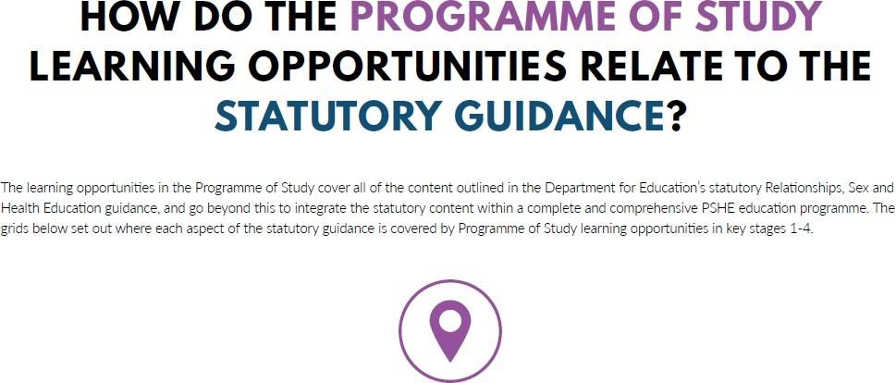

10

12. RELATIONSHIPS EDUCATION (PRIMARY)

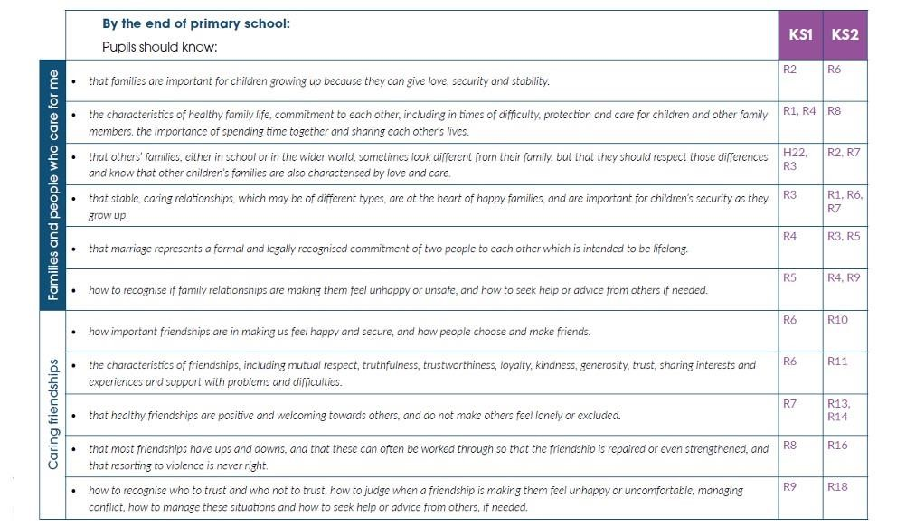

2

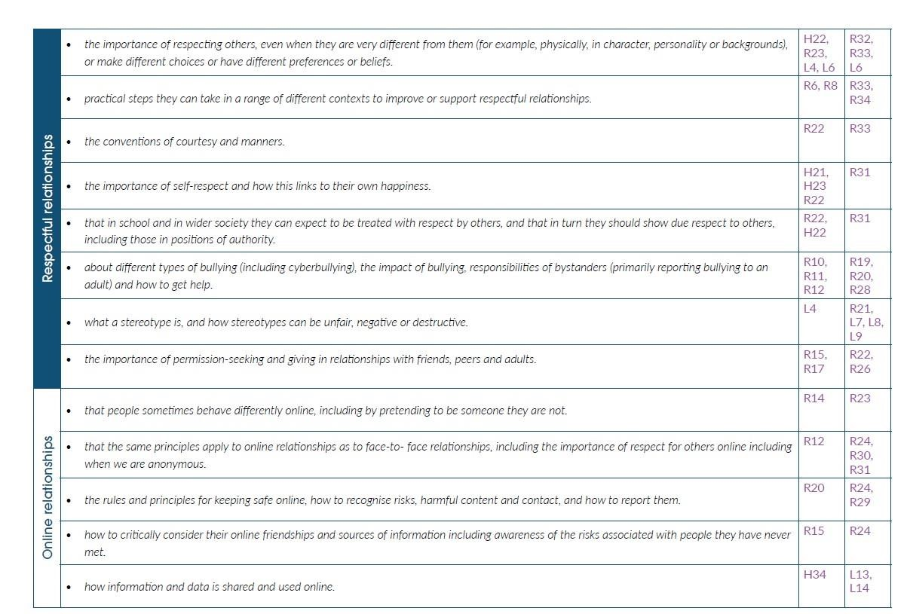

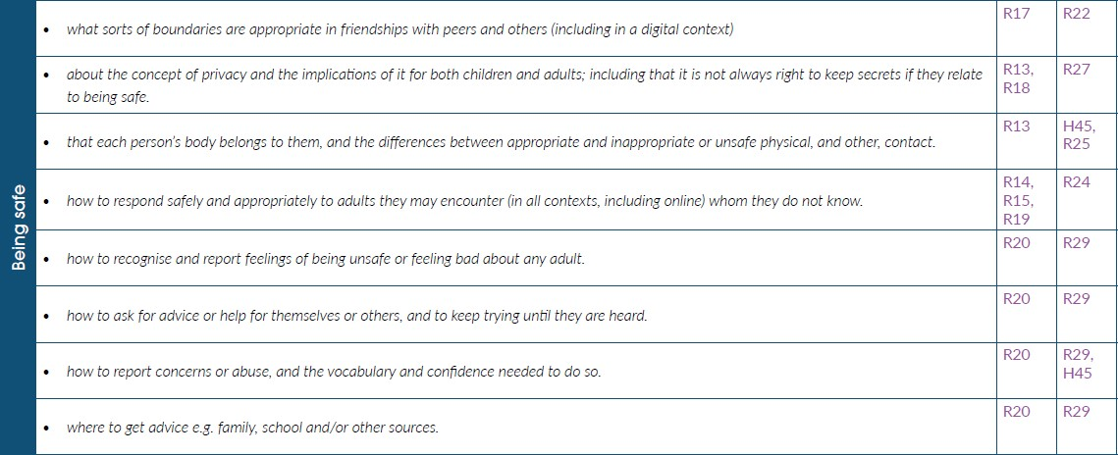

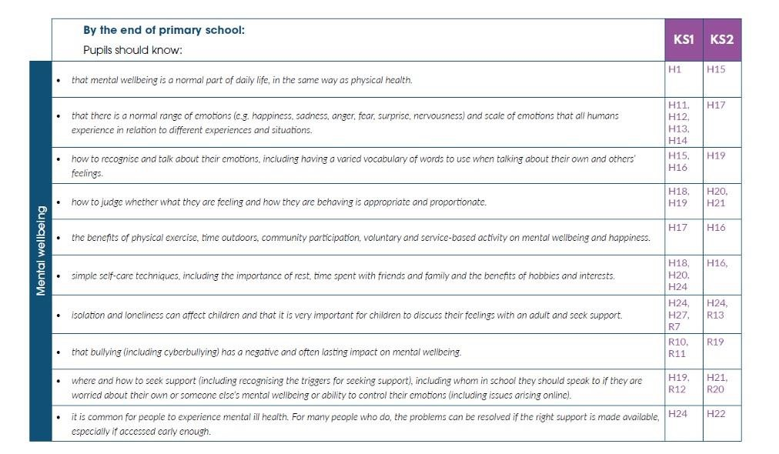

13.

HEALTH

EDUCATION

(

PRIMARY

)

