Year 6 – Video – Knowledge Organiser
Prior Learning: independently take photographs/videos, discuss and evaluate work, to edit sound

Facts | Vocabulary
1. Things to consider when making a movie:  A lot goes into making movies and here are a few things to consider when planning and making your own:  - What is the content of your movie? What genre does it fall into?  - Location—where will your film be set?  - Props— what costumes, items and objects will you need to create your movie?  - Sound—will you have sound effects within your movie? Will you need a soundtrack?  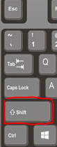 | 1. Panning - swivelling a still or video camera horizontally from a fixed position.  2. Tracking - any shot where the camera follows backward, forward or moves alongside the subject being recorded.  3. Running time—the length of duration of a film.  4. Genre—a category i.e. comedy, thriller, horror, romance etc.  5. Trim – to take off either the beginning or the end of a video clip  6. Split – cutting a video clip into separate pieces  7. Transition – Connecting one shot to another
2. The purpose of camera angles

- Camera shots are the building blocks of film, and shot selection has a huge impact on the way a viewer interprets the action on screen.
- There are a number of different angles you can consider using when making movies:
⇒ Extreme close up—where an object, item or body part fills the frame. This angle can heighten emotion.

⇒ Close up—shows the character from the should to the top of the head, good for capturing facial expressions.

⇒ Mid shot—shows the character from waist to the top of the head. Used for facial expression and capturing body language.

⇒ Long shot—shows the full length of the body from feet to top of head. Used to show the character in relation to their surroundings.

⇒ Extreme long/wide shot—establishing shot at the start of a film or scene.

3. How to import and edit videos in iMovie
- Import video
- Click on create movie, this will allow you to add any videos already on
your device. If you later want to add more photos/videos click the ‘+’ icon

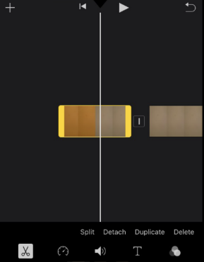
- Split video
- Find the point where 4. Add transitions
you want to split a video - Tap the icon in between
and tap ‘split’ clips and choose your
preferred transition
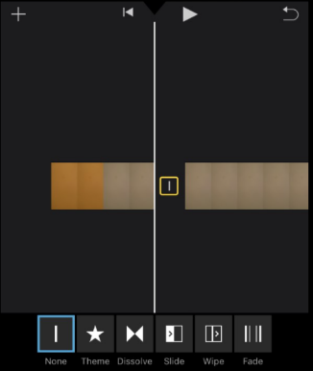

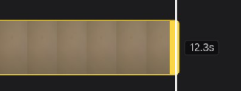
- Trim video
- Tap on the video so it
Highlights yellow.
- Drag it to the point you’d
like the clip to start/end
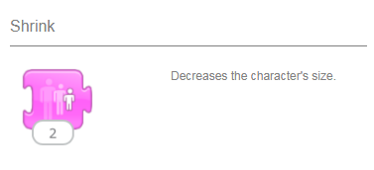

https://www.macworld.co.uk/how-to/imovie-iphone-3680016/

