Year 6 – HTML
Prior Learning: understanding that anyone can author on the internet , begin to understand that copying text from a website is the equivalent to stealing (plagiarism ), begin to understand that what is on peoples’ websites belongs to them, understanding what digital citizenship is

Facts | Vocabulary
- How are web-pages made?  - The information available on web servers (web pages) is written in a special type of code that Tim Berners Lee invented.  - The code is called HyperText Markup Language, or HTML for short.  - The concept of ‘hypertext’ (text you can click on to read about something else) has been around since the 1960s, but it was Tim Berners Lee who saw its potential for information stored on web browsers. | - Marking up – putting tags around the text to allow them to be understood by web browsers
- What is HTML?  - HTML is coding language that consists of a standard set of codes, or ‘tags’, that website authors insert into plain text documents to format them for the Web.  - HTML tags are used in pairs, one before and one after the word or group of words that the site author wants to format. The closing tag is exactly the same as the opening tag with one small difference, it has an extra forward slash (/).  - The tags ‘mark up’ the text by telling browsers how to display it. | - How to write HTML:  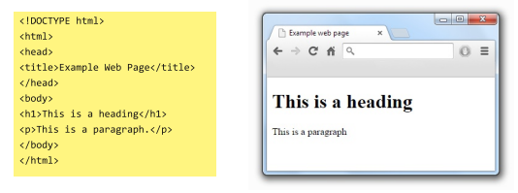  See below for a nice, simple example of HTML in action:  - The text inside the <title> tag defines the page’s title. The <h1> tag is defined as a heading. The text inside the <p> tag is defined as a new paragraph. Note the forward slash at the end to close each of the tags.  - You can view the HTML code language of any web page. Just right click on the webpage and press ‘View Page Source’.  