Year 6 – E-Safety
Prior Learning: understanding that anyone can author on the internet , begin to understand that copying text from a website is the equivalent to stealing (plagiarism ), begin to understand that what is on peoples’ websites belongs to them

Facts | Vocabulary
1. What is copyright?  - A copyright is a law that gives the owner of a written document, musical composition, book, picture, or other creative work, the right to decide what other people can do with it.  - Because of copyright, a work can only be copied if the owner of the copyright gives permission. | 1. Restrictions—the act of limiting something.  2. Infringing- breaking the terms of.  3. Civil law – Non-criminal law.  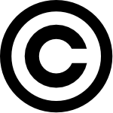  The copyright symbol
2. What are the implications of breaking copyright laws?  - When someone copies or edits a work that is protected under copyright without permission, the owner may sure for the value of the violation.  - Most cases are handled by civil law.  - In more serious cases, a person who copies a work that is protected under copyright could be arrested, fined or even go to prison.  - In recent years, Google and Apple have been involved in court cases where Apple’s Steve Jobs claims that Google’s Android system was ‘stolen’.  - Similar cases are due to take place in the music industry. Ed Townsend, who is the beneficiary of some of Marvin Gaye's copyrights and a co-creator, is arguing that Ed Sheeran's song "Thinking Out Loud" is infringing on some of Marvin Gaye’s music as it takes from the melody, harmony, and rhythm. | 3. What is plagiarism?  - Plagiarism is copying another person's ideas, words or writing and pretending that they are one's own work.  - It can involve violating copyright laws.  - There are many different types of plagiarism but two worth noting are:  - Direct Plagiarism - copying and pasting someone else's work, or making minor changes to someone else's work to pass it off as their own.  - Accidental Plagiarism - This can happen when a student does not cite their sources. It can also happen when a student paraphrases information without giving attribution (credit to the original author or authors).  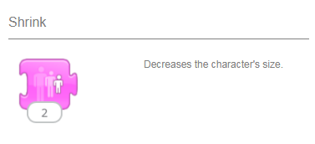  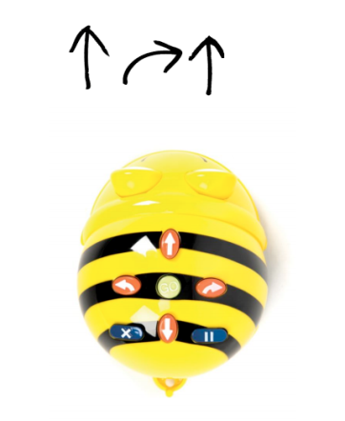
Youtube:

https://www.youtube.com/watch?v=ngKGGoqFKTI - plagiarism and copyright for beginners

