Year 5 – Networks
Prior Learning: understanding that anyone can author on the internet , begin to understand that copying text from a website is the equivalent to stealing (plagiarism ), begin to understand that what is on peoples’ websites belongs to them, understanding what digital citizenship is

Facts | Vocabulary
- Different Types of Networks  - Local Area Network (LAN)  - Wide Area Network (WAN)  - Local simply means over a small geographic area, while wide means over a very large geographic area.  - The internet is nothing more than a network of computer networks that allows things to move around (email, web pages, apps and games).  - The network in your home and the computers used by Amazon, are all connected together by one big ‘network of networks’ which is the internet. | - IP Address – computers use an IP address (Internet Protcol) to identify each other. It’s a bit like a postcode that is unique to each computer connected to the internet. An IP address is a set of numbers that might look like this: 195.188.87.10.  - DNS – Domain Name System is a set of standards for how computers exchange data on the internet. The DNS turns a user-friendly domain name like bbc.co.uk into an IP address.  - Router – a smart device that directs or routes information around the internet. When a data packet arrives the router reads the IP address information and sends the packet along the best route to its destination.
- Data Packets  - When information is being sent from one computer to another it is broken down into small bits of data called ‘packets’. Each packet includes information about where the data is going to, where it is from and how to reassemble it.  - The small packets can be passed quickly through the internet to the receiving computer where they are reassembled into the original data.  - The process happens so quickly that high definition video can be watched this way, normally without any glitches.  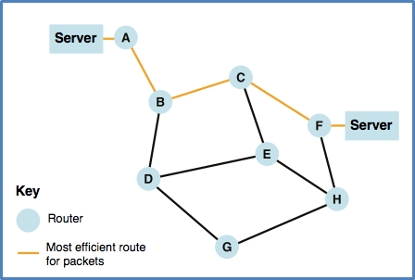  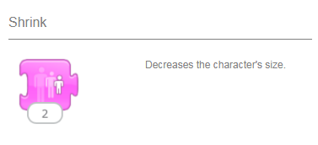    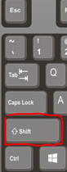   | - Wireless Devices  - A range of devices may connect to a local area network wirelessly.  - These could be laptops, tablet devices, phones, smart speakers such as Google Home and Amazon Echo, wearables such as Fitbits or Apple Watches or home smart meters used to measure household consumption.  - A wireless router enables devices to connect to the local area network by routing data across a wireless connection.

