Year 5 – Presentations using Microsoft Excel Knowledge Organiser
Prior Learning: planning an animation, use a sequence of images to create a short animated sequence, independently take photographs/videos, discuss and evaluate work.

Facts | Vocabulary
1. How can I open the Excel application?    Go to the search bar and type in ‘excel’. Click on the green symbol to open up the application. | Excel - a software program created by Microsoft that uses spreadsheets to organize numbers and data with formulas and functions.  Pie chart - a type of graph in which a circle is divided into sectors that each represent a proportion of the whole.  Data - facts and statistics collected together for reference or analysis.  Design - a decorative pattern.
2. What is a pie chart?  Pie charts can convert one column or row of spreadsheet data into a pie chart.  - It is another format to represent data.  - Each slice of pie (data point) shows the size or percentage of that slice relative to the whole pie.  - Pie charts are best to use when you are trying to compare parts of a whole.  - Pie charts work best when: You have only one data series.  - Unlike bar charts, they don’t show results over time.  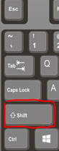    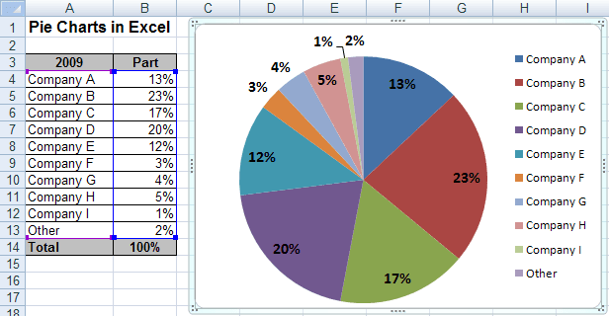 | 4. How can I create a pie chart on Microsoft Excel?  - You must create a table with data in on Excel.  - From here, click the ‘insert’ tab and you will see a pie chart symbol.  - Click the pie chart button and a variety of pie chart templates will appear.  - Choose the pie chart of your preference – the charts can be in 2D or 3D.  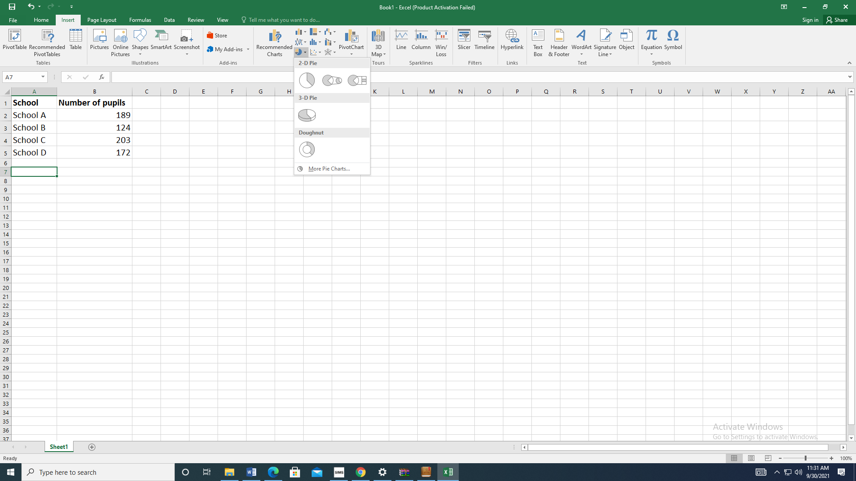  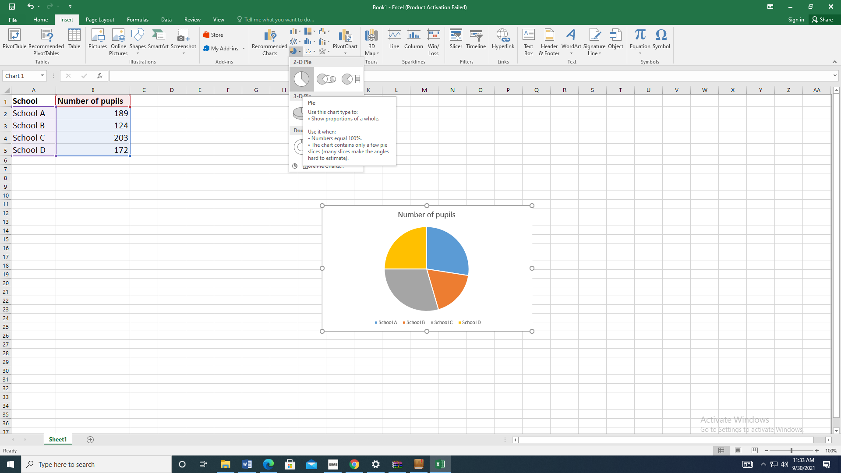  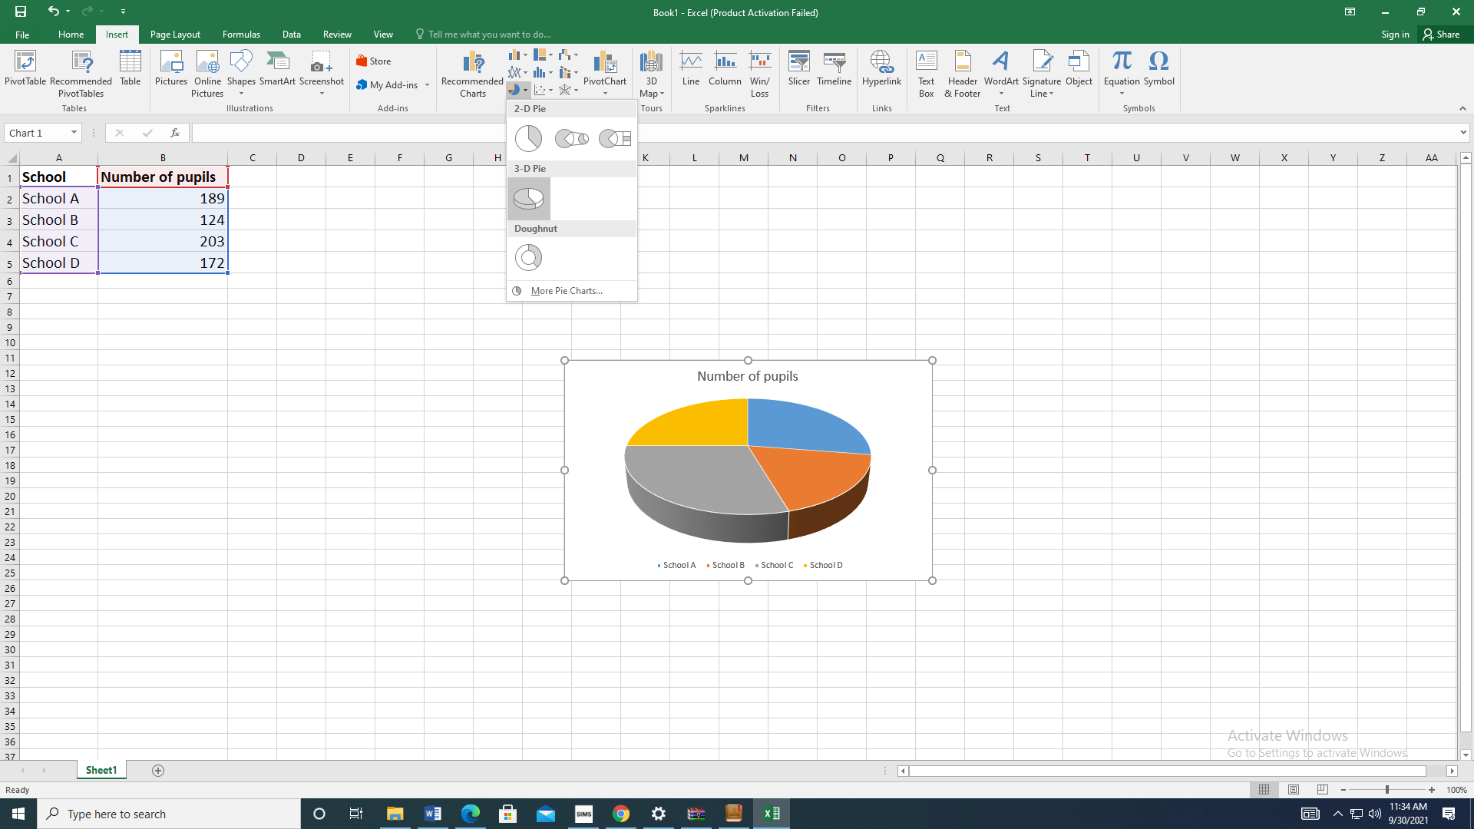  6. How can the colours be changed?  - Click ‘colour changes’ on the far left.  - Options of ‘colourful’ or ‘monochromatic’ can be selected.  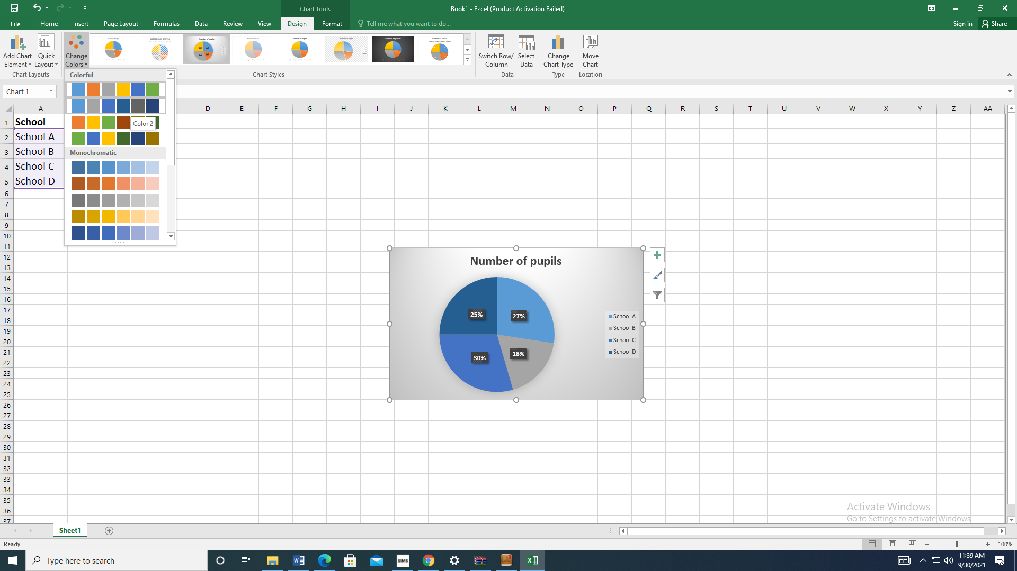  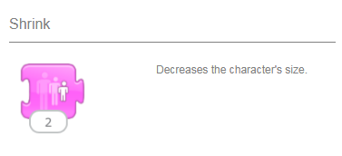  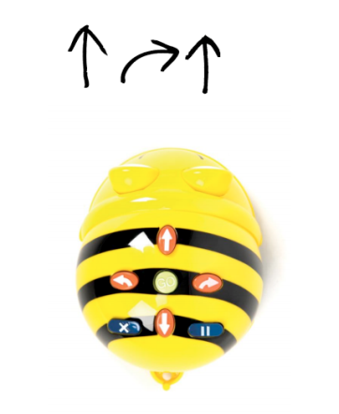
- Who are pie charts useful for?
- Pie charts are used to show data and represent the results clearly.
- Businesses, managers, students, companies using stock markets and those tracking data use pie charts.
- An example would be a business showing their market size by showing how much of the market a particular shoe company has.
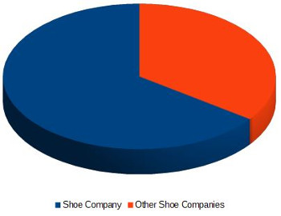
- How can I change the design of my pie chart?
- Click on the ‘design’ tab after choosing the preferred pie chart.
- Here the pie chart style can be chosen from the templates.
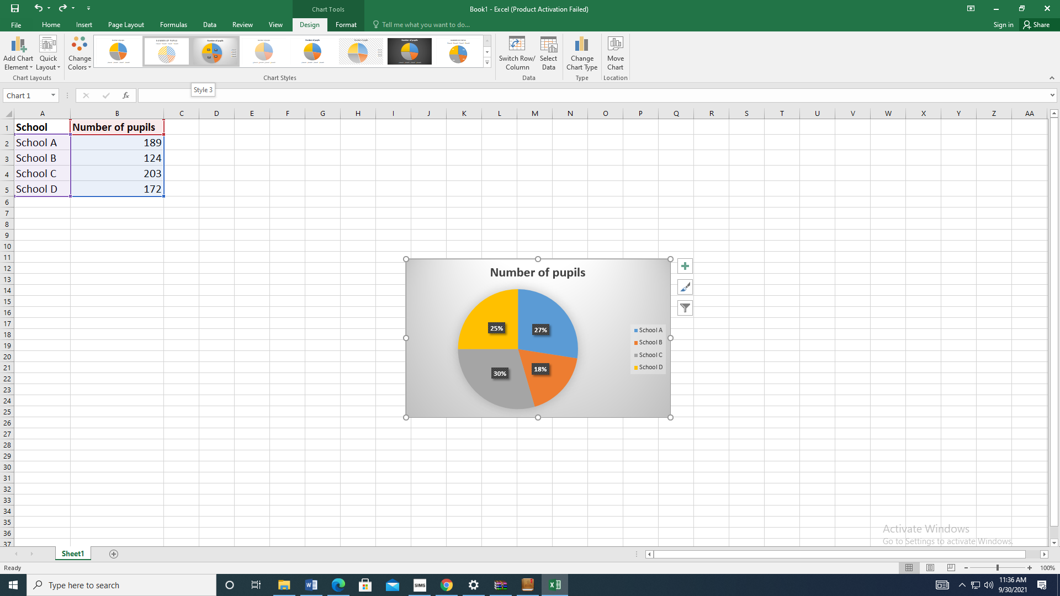
https://www.youtube.com/watch?v=ctD-6XNAms8

https://www.youtube.com/watch?v=hElkEzAjd5o

https://www.google.com/search?q=how+to+create+a+pie+chart+on+excel+for+kids&rlz=1C1GCEU_enGB963GB963&oq=how+to+create+a+pie+chart+on+excel+for+kids&aqs=chrome..69i57.6128j0j4&sourceid=chrome&ie=UTF-8#kpvalbx=_J8tVYYjDJ6eZjLsPg5CquAo18

