Year 4 – E-Safety
Prior Learning: online and offline, SMART rules, what a web browser is, email is a good form of communication, how to use a search engine to find a picture, personal information should be kept private from strangers online

Facts | Vocabulary
- What is a digital citizen?  - Being a digital citizen means you are a part of the group of people that use technology to communicate.  - There are rules that you need to follow when you are digital citizen, to protect yourself and to protect others:  - Respect yourself and others online  - Stay safe online  - Carefully manage your digital footprint  - Protect private information for yourself and others  - Balance the time you spend online and using media | - Citizen - an inhabitant of a particular town or city.  - Restrictions – a limiting condition or measure, especially a legal one.  - Manipulative - exercising unscrupulous control or influence over a person or situation.  - Malicious - characterized by malice; intending or intended to do harm.
- What restrictions are in place on social media?  - Social media is website and applications that enable users to create and share content or to participate in social networking.  - Nearly all social media services require their users to be at least 13 years of age to access and use their services. This includes:  - Facebook    - Snapchat  - TikTok  - Instagram | - Why are restrictions in place on social media?  - These restrictions are in place to protect users and should be adhered to.  - They can help to protect you, others and your personal information.  - Most popular social media services don’t allow anyone under 13 to join.  - Even so, lots of younger children manage to set up accounts.
- Fake News  - Fake news is news or stories on the internet that are not true. There are two types of fake news, disinformation, and misinformation.  - Disinformation is false information that’s created and shared to deliberately cause harm.  - Misinformation is generally used to refer to misleading information created or disseminated without manipulative or malicious intent. | - Cyberbullying  - Cyberbullying is when a child is tormented, threatened, harassed, embarrassed or targeted by another child using the internet, interactive and digital technologies or mobile phones.  - If you feel you are the victim of cyberbullying or someone you know is, speak to a trusted adult.  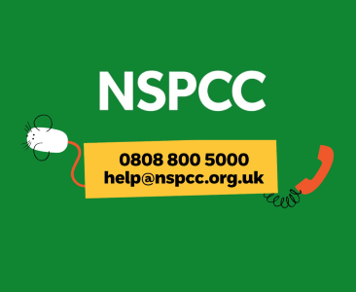  - You can also call Child line or the NSPCC (National Society for the Prevention of Cruelty to Children).  

