Year 4 – Audio and Video – Knowledge Organiser
Prior Learning: acquire, retrieve and store images, modify images in a paint program uses various tools for purpose, create a sequence of images to form a stop motion animation or slideshow

Facts | Vocabulary
1. Input and output devices  - Input devices – A microphone, which will record sound  - Output devices – Speakers or headphones, which will playback audio | 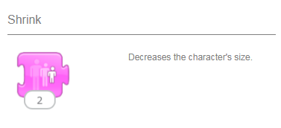  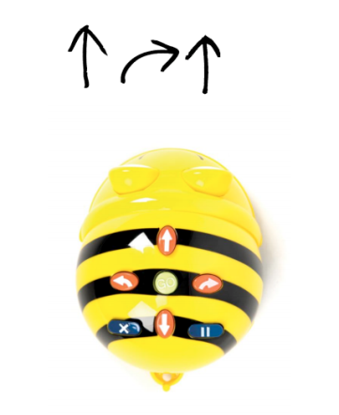  1. Video – recording of moving visual images made digitally or on videotape  2. Input – Data that a computer receives  3. Output – Data that a computer sends
2. Film Trailers  - Voice over introduces film and uses adjectives to excite the audience  - Production logo  - Scenes from the film included (sometimes with dialogue)  - Title of the film (Also announced by voice over)  - Sometimes quotes are included from reviews  - Music may be included  Disney Pixar’s ‘Brave’ trailer - https://www.youtube.com/watch?v=TEHWDA_6e3M  ‘Matilda’ trailer –  https://www.youtube.com/watch?v=pnzLRDDijW0 | 4. How to edit section of an audio recording (GarageBand)  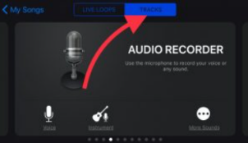  - Select audio recorder  - Then click record red button, wait for the audible clicking and on-screen countdown before speaking.  - Once you have finished speaking, press the white square stop button to stop recording.  - Choose your voice effect  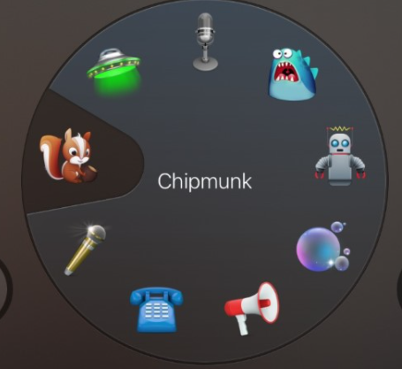  - Click on the below tab to view your audio    - Now you are able to edit the audio, choose whether to cut, copy, paste, loop, split, delete or rename.  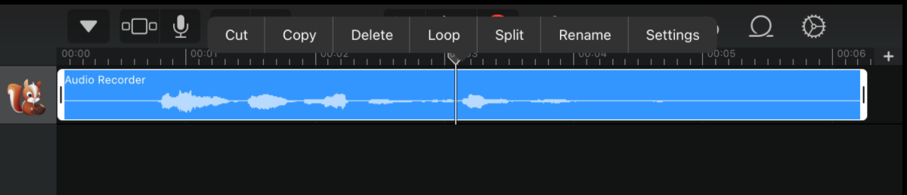
3. How store a video on a computer
- Attach the device the video was filmed/saved on
- Copy or move to your chosen location in your documents
- Choose the name of your video and press enter
