Year 2 – Word Processing Skills Knowledge Organiser
Prior Learning: Write their name using a keyboard on different devices, use shift or caps lock for the initial sound in their name, choose an application to draw with
Facts | Vocabulary
1 – How can I insert Word Art as a title?  - Microsoft word has a feature called ‘Word Art’.  - Word Art can be used to create titles and subheadings.  - Word Art is visually captivating and can gain the reader’s attention.  - Because of this, we can create posters on Microsoft Word.  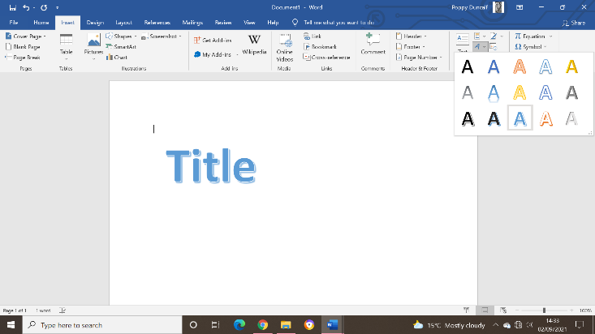 | - Microsoft Word- Software programme  - Font – the style of text.  - Word Art – a gallery of text styles to create decorative effects.  - Copy and paste – to place exact images or text in a new place.  - Text box – a location where text can be added.
2 - How can a variety of fonts be created on Microsoft Word?  - A range of fonts can be used such as ‘Wide Latin’ and ‘Lucida Handwriting’. A variety of colours for the text can also be applied.  - These variations can separate and organise information and make the poster look more exciting.  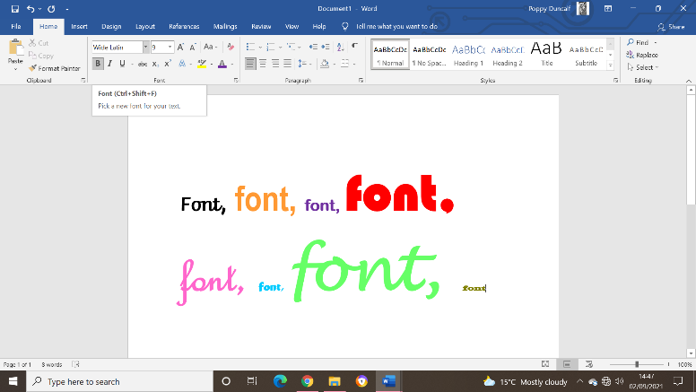 | 4 – How can I insert a text box?  - A text box can be created to place information in a certain area on the document.  - These can be used to separate information into paragraphs. There are a range of styles to choose from.  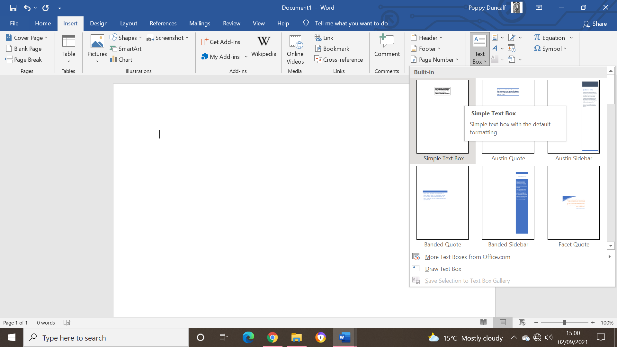  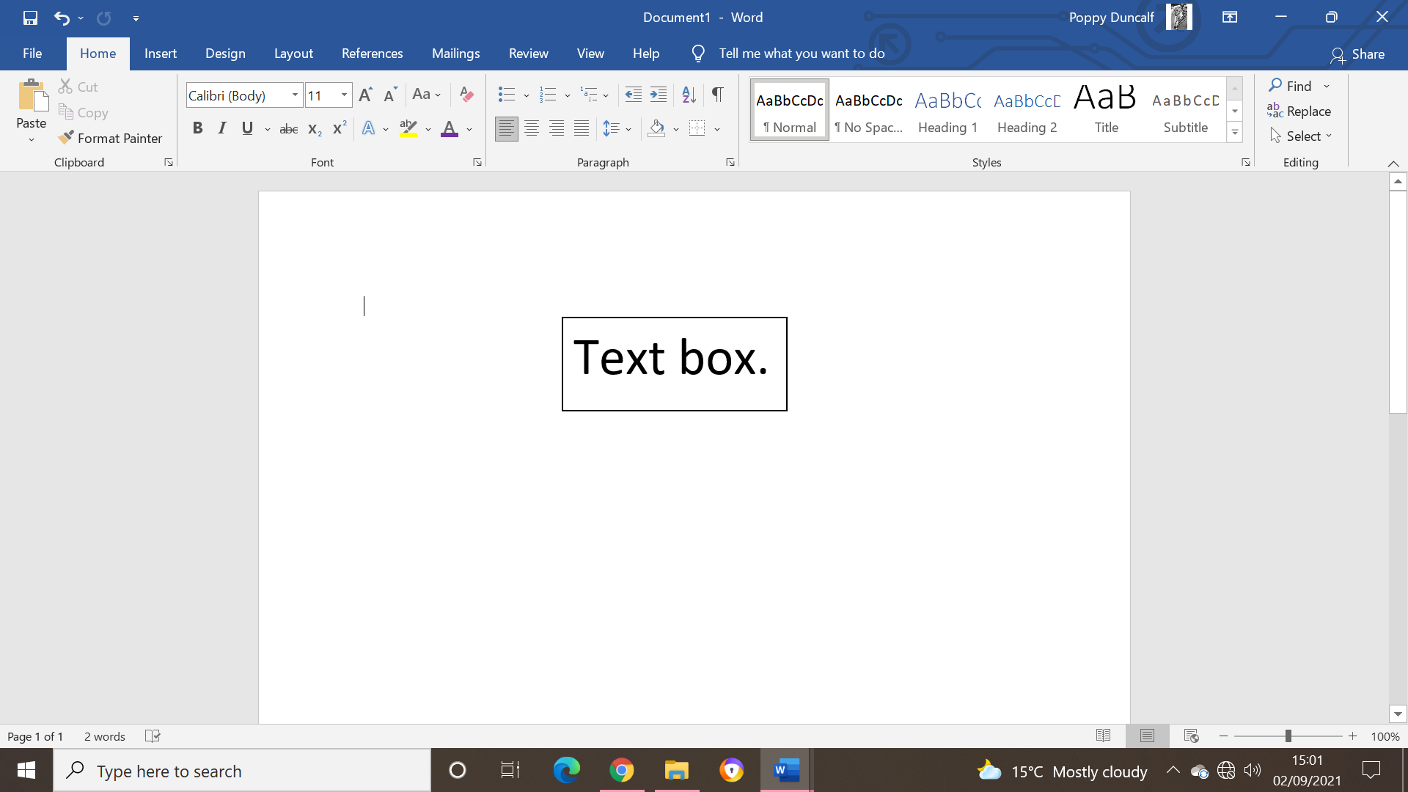
3 – How can I insert images onto Microsoft Word?  - Images can be added to a Word document.  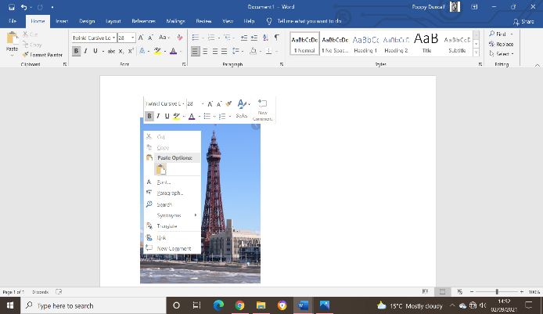  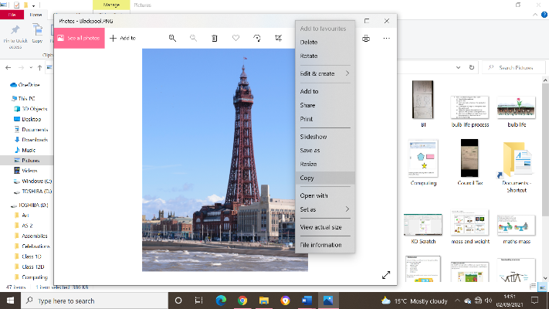  - This can be done by copying and pasting images from the photo album on the desktop. This format can also be used when searching for images online. | 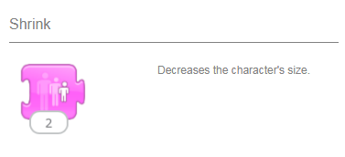  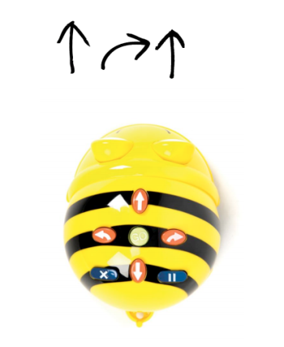  5 – How can I screenshot?  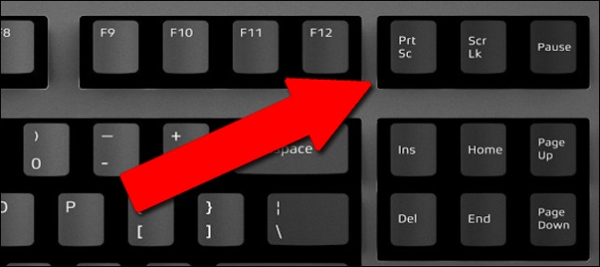  - Screenshots are a shortcut and effective way to insert an image into a document.

