Year 2 – Basic Stop Motion – Knowledge Organiser
Prior Learning:

Facts | Vocabulary
1. What is an animation?  - Animation is the process of giving the illusion of movement to drawings, models, or inanimate objects.  - Animated motion pictures and television shows are highly popular forms of entertainment.  - Animation has developed and advanced greatly over the years. | 1. Animation – process of creating motion through individual frames.  2. Stop motion – technique whereby the camera is stopped and started to suggest movement.  3. Claymation – animation of models constructed from clay  4. Frame - contains the image to be displayed at a unique time in the animation
2. Who is Nick Park?  - Nick Park, in full Nicholas Wulstan Park, (born December 6, 1958, Preston, Lancashire, England), British animator and director of stop-motion films that often feature his characters Wallace and Gromit.  - Wallace and Gromit is a type of stop motion animation called Claymation.  - The feature length film ‘Curse of the Were– Rabbit’ took 15 months to film as the creators had to manipulate and move the clay models.  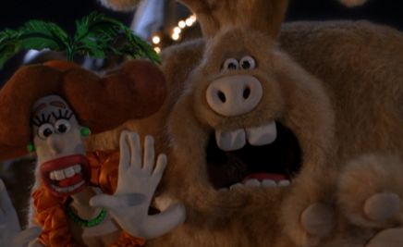  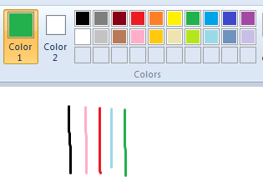  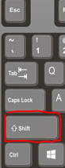  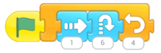 | 3. What is stop motion animation?  https://www.youtube.com/watch?v=wVjMFU11hVA  - In stop motion animation objects are physically manipulated in small steps.  - This is done between individually photographed frames so that they appear to move independently when the e series of frames is played back in fast sequence.  - One second of stop motion animation is made up of 12 frames.  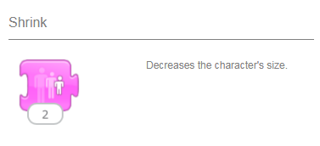  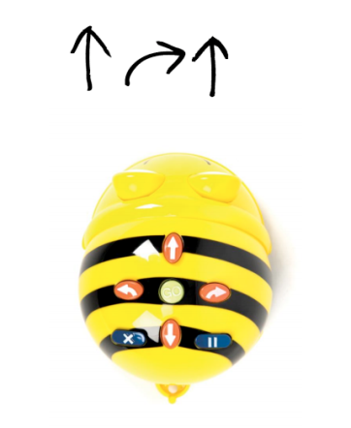  - Creating stop motion animation can take a considerable amount of time.
4. What is a storyboard?  - Animations include a narrative and characters  - Animators use a storyboard to plan the scenes  - Remember each scene will probably need several animation frames.  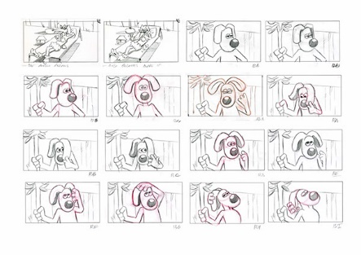 | 5. How to create a stop motion animation (Using Stop motion studio)  - Open the app and hit + New Movie. Make sure the shot is framed properly and hit the camera icon in the top right corner  - Hit the record button to take each shot, moving your scene along in between. The smaller the movements, the smoother the animation will be. (Use the timer button above the record button if you want to automatically take shots at a regular interval)  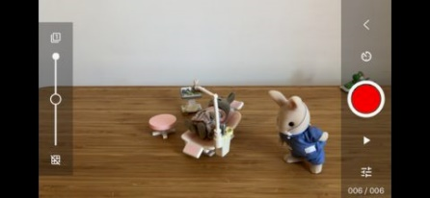  - Hit the Play button below the shutter button to instantly preview your animation.

