Year 1 – Programming Toys
Prior Learning: Develops digital literacy skills by being able to access, understand and interact with a range of technologies, Completes a simple program on electronic devices, Begin to list different IT in their home

Facts | Vocabulary
- What are instructions?  - Instructions are written for someone who needs to know how to do something.  - They are written in step by step points.  - They are written in chronological order.  - They can be written in words or using pictures.  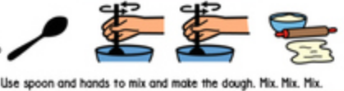 | - program — a sequence of instructions/algorithm written to perform a task  - debug— finding problems/mistakes in instructions/algorithms and fixing them.  - chronological order— the order in which something has happened or is done
- What is an algorithm/program?  - An algorithm or program is a set of instructions completed in order to achieve a task.  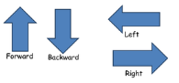  - Programs are created using programming language.  Some simple commands used are:  1. Forwards  2. Backwards  3. Left  4. Right | Bee-Bots can be programmed to go forwards, backwards, left and right.  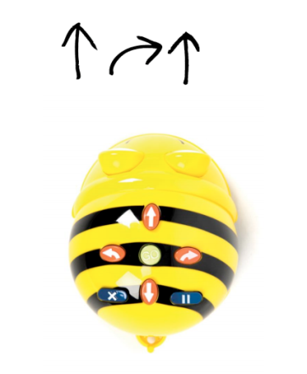  • Some sets of instructions can have bugs or mistakes in them.  • You have to find the bug and fix it.  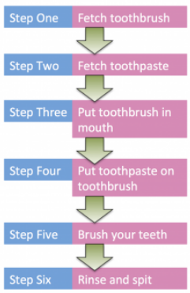
- What is debugging?

A problem or error in a code is called a ‘bug’
If a program doesn’t work we look for the error and fix it.
This is called ‘Debugging’

Youtube:

https://www.youtube.com/watch?v=52ZuenJlFyE - Bee-Bot introduction

https://www.youtube.com/watch?time_continue=1&v=CGPjraqX_ac - Debugging introduction

